Hands-on Lab: Processing Documents from the Shop Floor with SAP Build & Document AI

Gabe Mensching, Vass, [gabe.mensching@vasscompany.com](mailto:gabe.mensching@vasscompany.com)

Michael Pytel, Vass, [michael.pytel@vasscompany.com](mailto:michael.pytel@vasscompany.com)

<https://vasscompany.com>

Index

Table of Contents

Environment Information 2

Explore Document AI 2

Create an Automation with SAP Build 5

# 

# Environment Information

* Please use GOOGLE CHROME as your browser
* SAP BTP URLs:
  + [Global Account Direct Link](https://amer.cockpit.btp.cloud.sap/cockpit#/globalaccount/2c774650-2712-4b97-93a8-bc558d875b64/accountModel)
  + [SAP Build Sub Account Link](https://amer.cockpit.btp.cloud.sap/cockpit#/globalaccount/2c774650-2712-4b97-93a8-bc558d875b64/subaccount/bf0d91cd-3031-4a2e-8358-bca1b2394970/subaccountoverview)
  + [SAP Document AI Sub Account Link](https://amer.cockpit.btp.cloud.sap/cockpit#/globalaccount/2c774650-2712-4b97-93a8-bc558d875b64/subaccount/4fd2abe1-6f99-4865-ad26-7fccc0a36377/subaccountoverview)
* SAP Build App URLs
  + [SAP Build Apps](https://vass-sap-build-ai2.us10.build.cloud.sap/)
  + [SAP Document AI Link](https://sap-document-ai-gcp.us30.doc.cloud.sap/)
* Lab User Information
  + User: **labuser<##>@vasscompany.com**
  + Password: Newpa55!
* Replace <##> with your Lab User Number assigned by the instructors

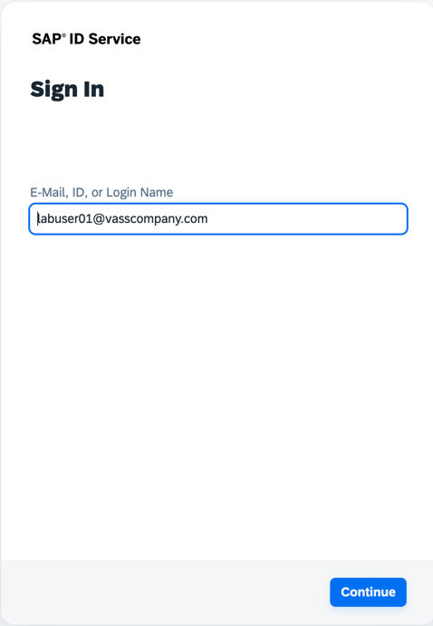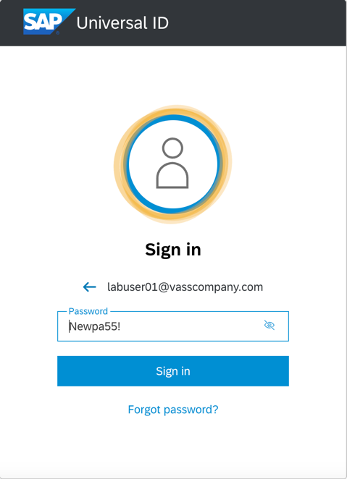

# Configure SAP Document AI

1. Open an Incognito Browser and navigate to the SAP BTP Cockpit
   1. <https://amer.cockpit.btp.cloud.sap/cockpit>
2. Navigate to the ‘SAP Document AI’ Subaccount
3. Navigate to *Instances and Subscriptions > SAP Document AI*
4. Click on the hyperlink to access the application

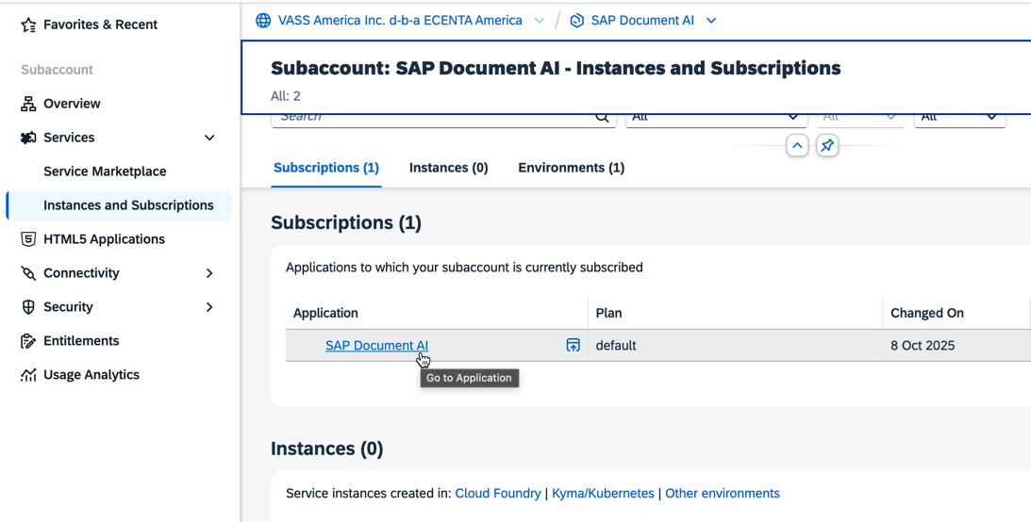

1. If prompted, enter your Lab UserID and Password
2. Next, we’re going to create a new custom schema to configure that data elements we want Document AI to extract from the documents we upload
3. Click on Schema Configuration from the left navigation
4. Then select Create

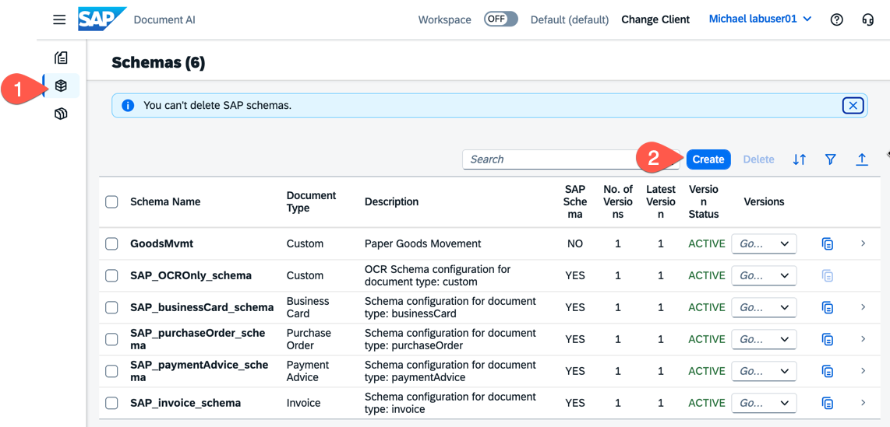

1. On the New Schema prompt enter the following data
   1. Name: labuser##_gm
   2. Description: Labuser## Goods Movement
   3. Document Type: Custom
   4. OCR Engine Type: Document
2. Click Create

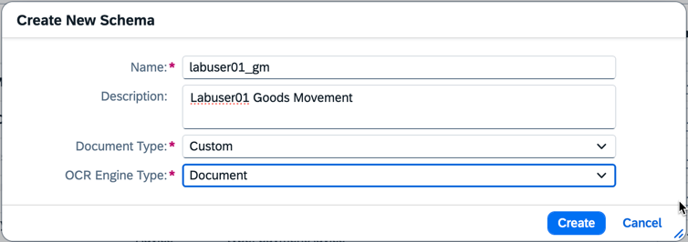

1. Next, click Add within the Header Fields section. Enter the data below
   1. Name: Source_Bin
   2. Label: Source Bin
   3. Description: Source Bin
   4. Data Type: String
   5. Setup Type: Auto
2. Click Save. And repeat for the following fields

|  |  |  |  |  |
| --- | --- | --- | --- | --- |
| Name: | Label: | Description | Data Type | Setup Type |
| Target_Bin | Target Bin | Target Bin | String | Auto |
| Product | Product | Product | String | Auto |
| Quantity | Qty | Quantity | String | Auto |
| Notes | Notes | Notes | String | Auto |
| UoM | UoM | UoM | String | Auto |

1. After you have entered all fields, click Activate.

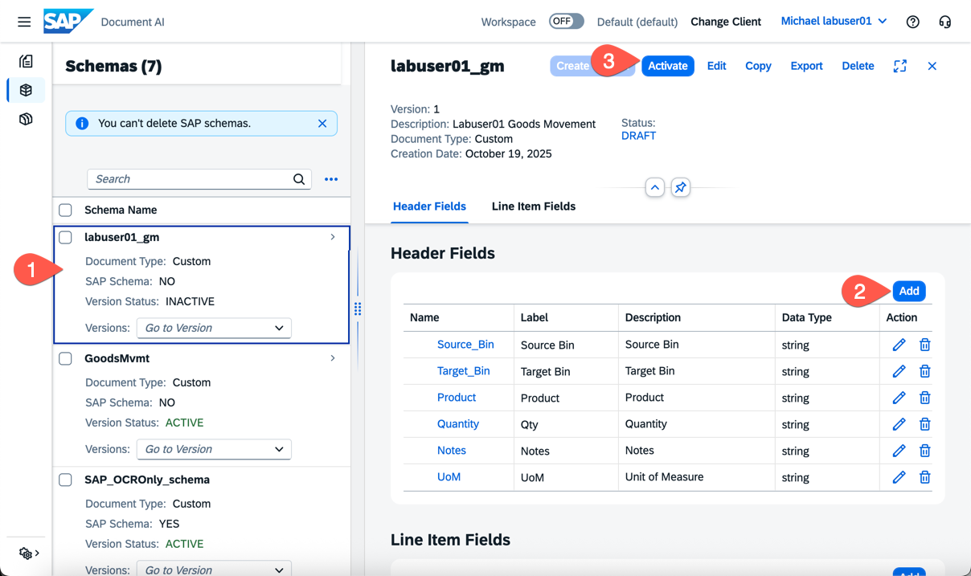

1. Next, we’re going to upload a document to process as a test scenario.
2. Click on Documents in the Left Navigation.
3. The click the + symbol to Upload a Document.

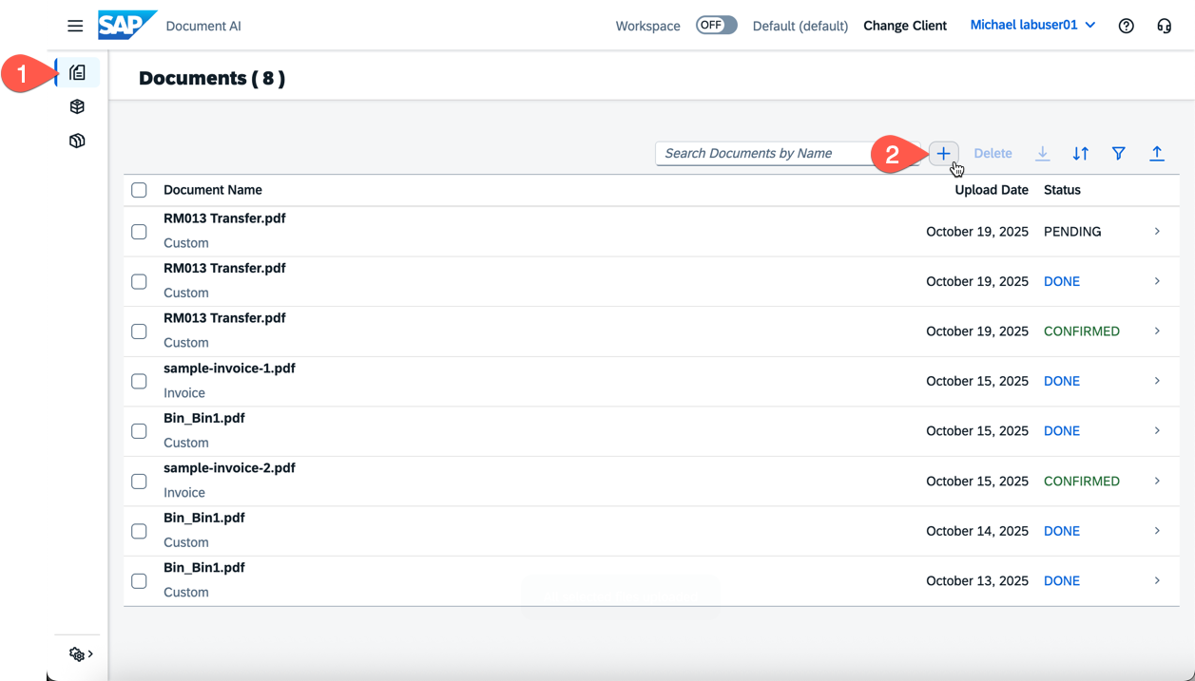

1. Select the following values from the Drop Down Displayed
   1. Document Type: Custom
   2. Schema: labuser##_gm
      1. Replace ## with your labuser number from above
   3. Schema Version: 1 (default)
   4. Template: Detect Automatically
2. Click the + symbol again to select a document stored locally
   1. The instructors will provide files to you before the lab
3. Once you’ve selected a document, click the Confirm Button

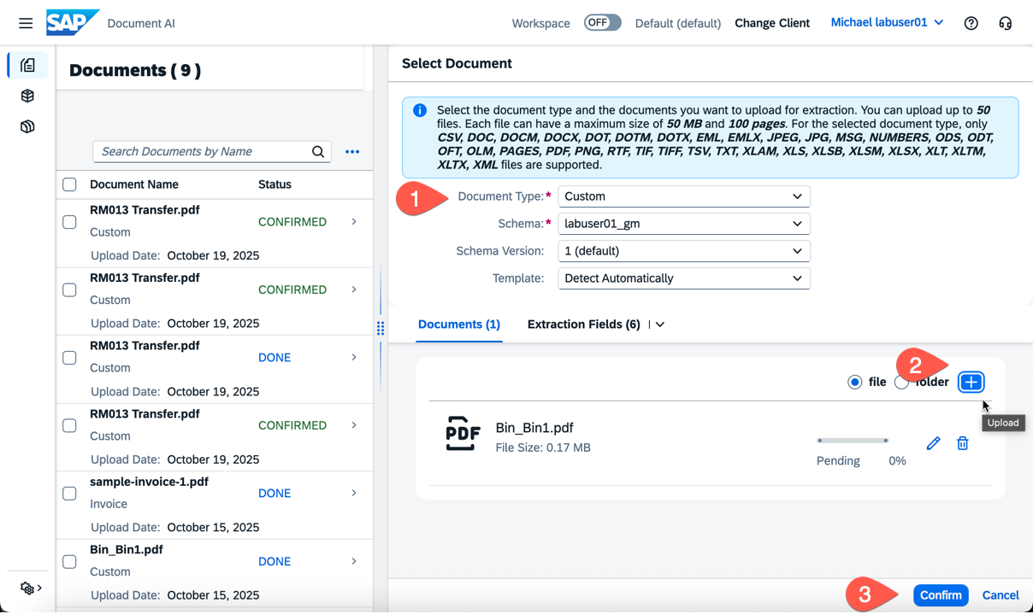

1. The *Status* will be displayed as PENDING initially. Wait 30-60 seconds and the status should update to DONE
2. Select your Document Line to view the results.
3. Select the Edit button to confirm or updated any results

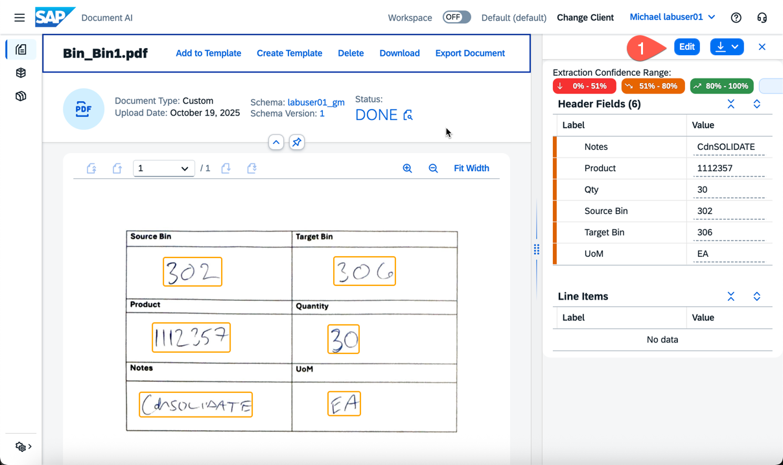

1. Congratulations! You’ve successfully defined a document schema for SAP Document AI to process! Documents upload via the Document AI API can be processed asynchronously and the resulting extracted output can be used in other processes.

# Create an Automation with SAP Build

1. Logon to SAP Build by directly clicking the link below
   1. [SAP Build Apps](https://vass-sap-build-ai2.us10.build.cloud.sap/)
   2. or by navigating to <https://amer.cockpit.btp.cloud.sap/> > Sub Account > SAP Build TDD > Instances & Subscriptions > Subscriptions > SAP Build Apps
2. If prompted, login with the Lab UserID information provided earlier
3. From the Lobby, click Create > Create

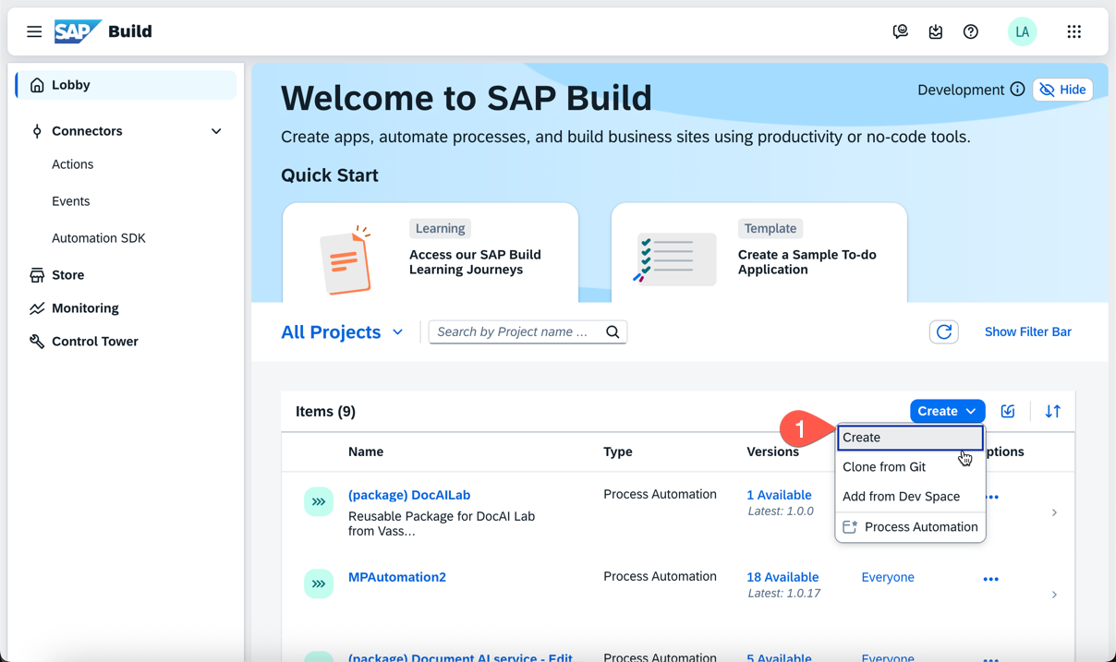

1. Select *Automation Process*

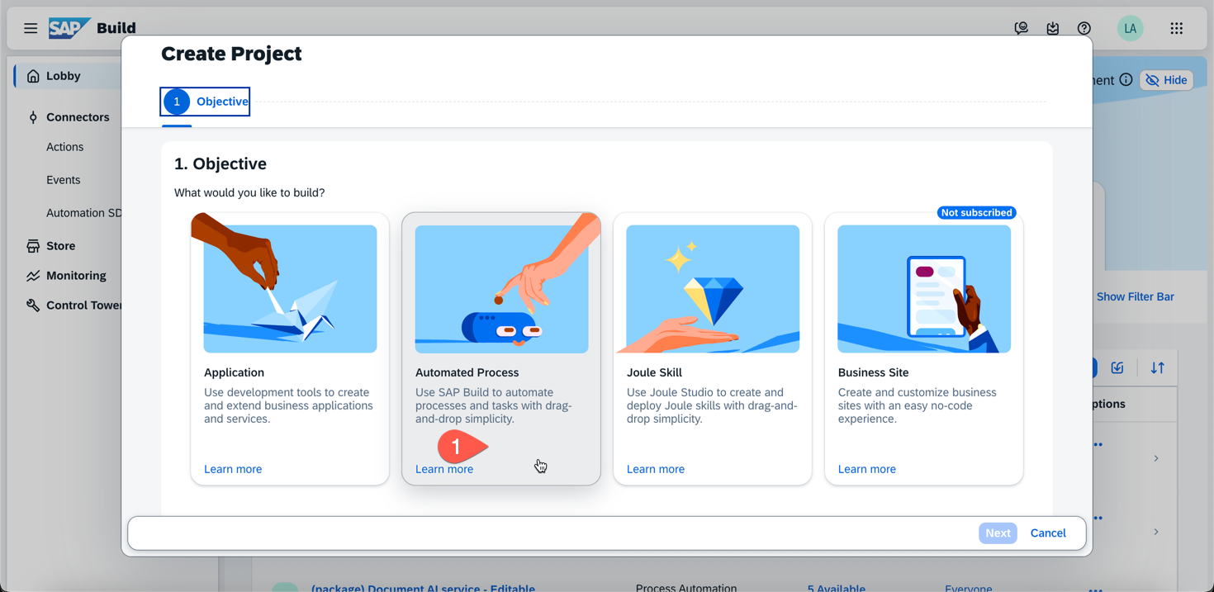

1. Select *Process*

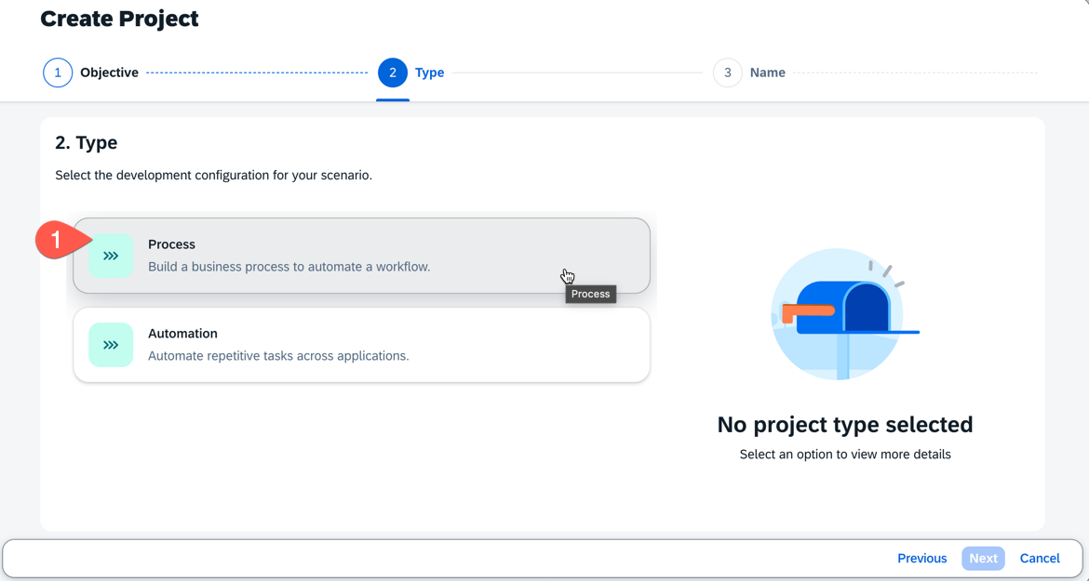

1. Enter the data below
   1. Name: Labuser##_DocAI
   2. Description: Labuser## Document AI

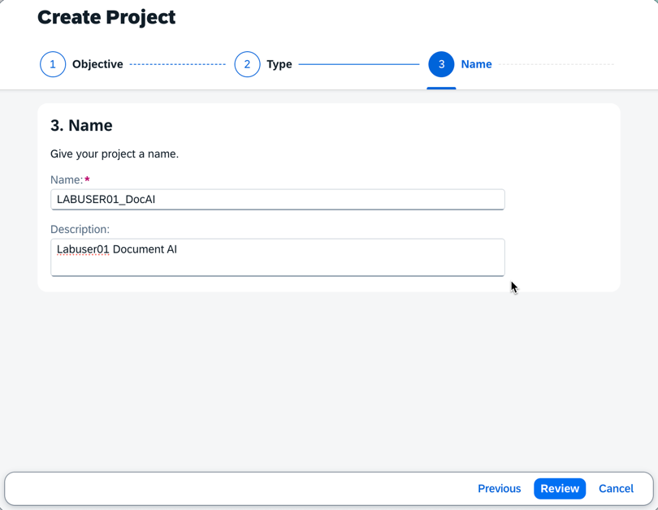

1. Click Review
2. Click Create
3. A new browser tab will open
4. Click ‘Accept’ if shown a disclaimer
5. Enter the following on the prompt to *Create Process*
   1. Name: Labuser##_Process
   2. Identifier: Labuser##_Process
   3. Description: Labuser## Process Documents

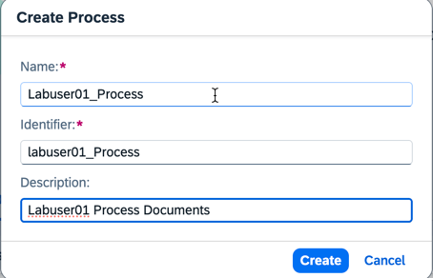

1. Before we add automations and processes we need to configure some additional settings.
2. Click the Settings  icon in the upper right
3. Navigate to *Environment Variables* and Click *Create*
4. Add the following Variables

|  |  |  |
| --- | --- | --- |
| Identifier | Description | Type |
| S4System | S4HANA System | Destination |

1. The variables should look like the below image when done.

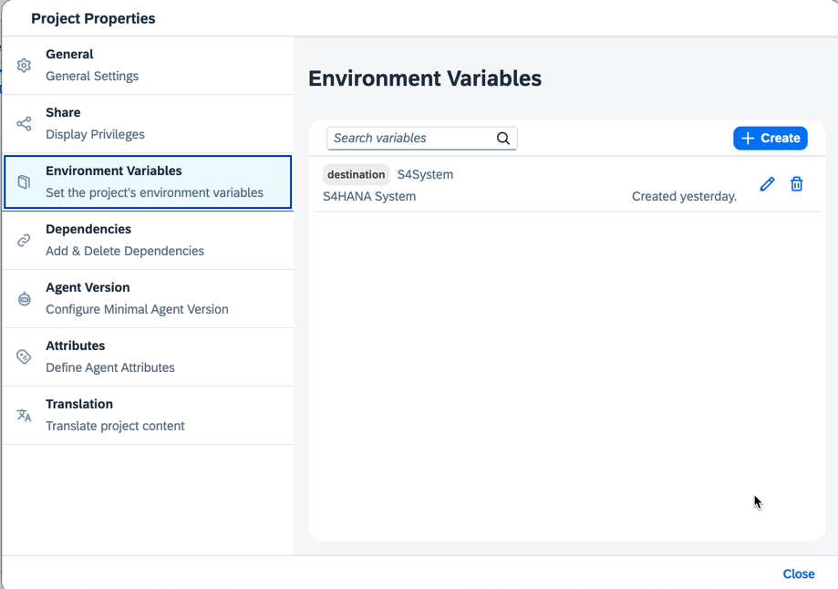

1. Next, navigate to *Dependencies* in Project Properties
2. Click Add > Add a Business Process Project Dependancy

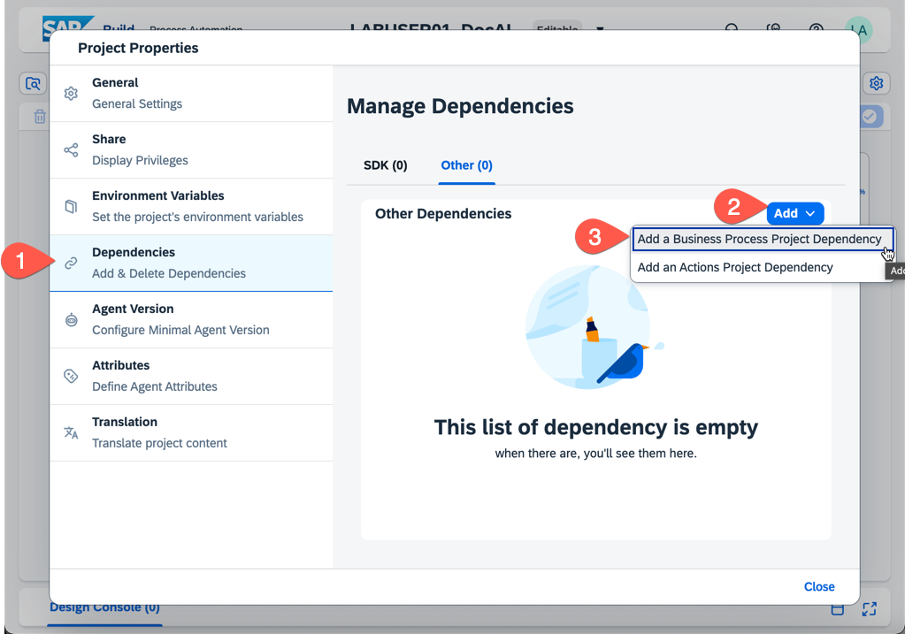

1. Add a dependency for the following packages
   1. (package) DocAILab {latest version}
   2. (package) Document AI service – Editable
2. Next, select Add an Actions Project Dependency and select the following
   1. Creates a material document / Project: S4 Material Documents - Read, Create
3. Your Project Settings Dependencies should look like the following screenshot.

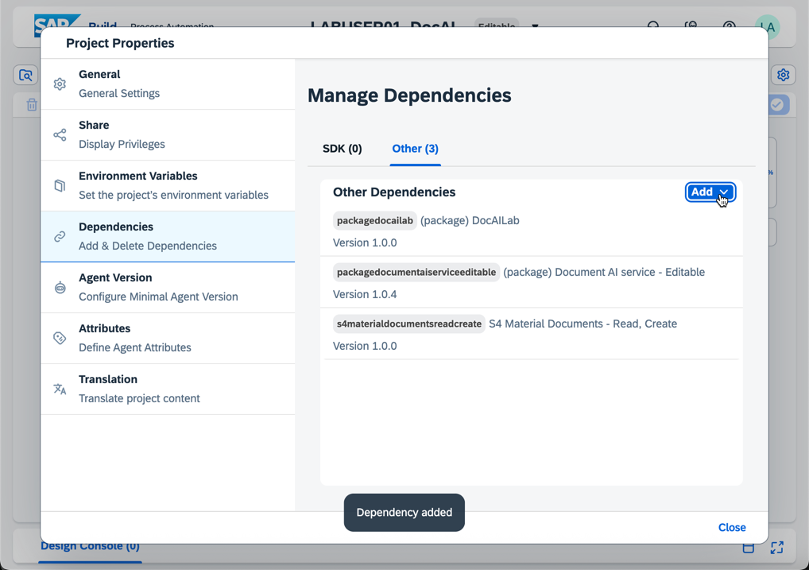

1. After adding your Environment Variables and Dependencies click *Close*
2. Select the button ‘Add a Trigger’

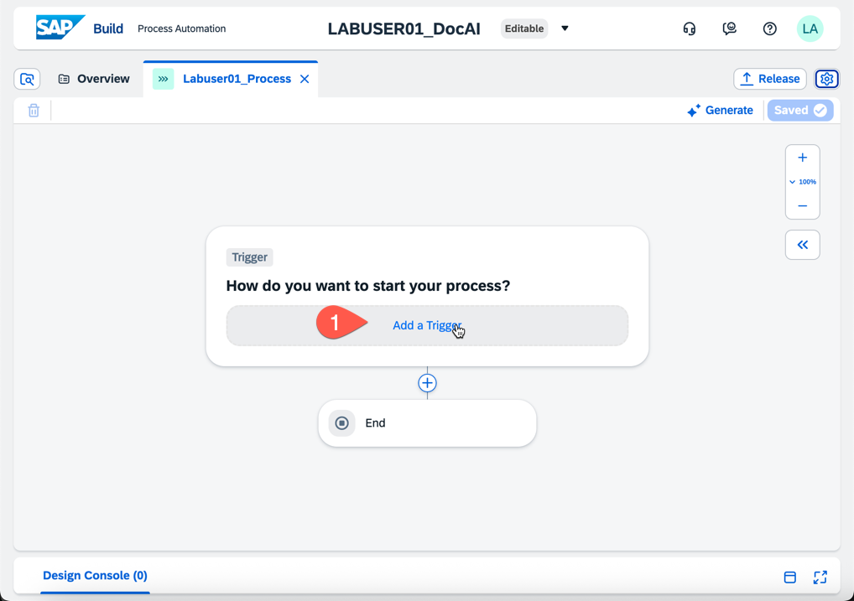

1. Select *Submit a Form*, on the next screen
2. Select *Create a New Form, Blank Form*

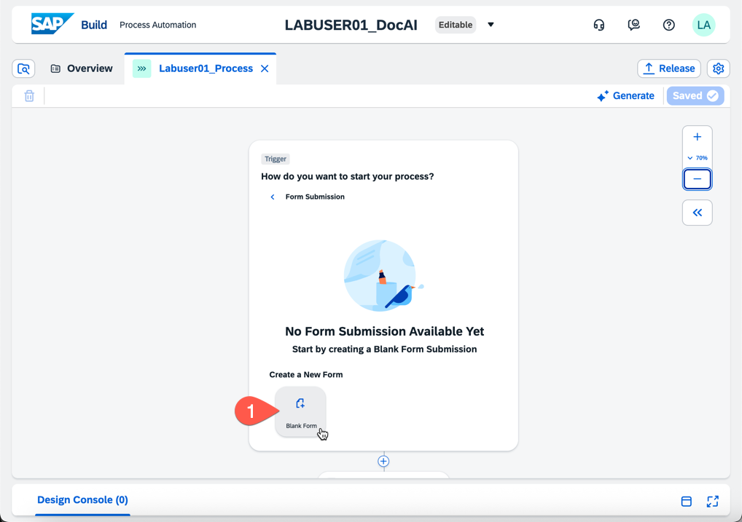

1. Enter a Name for the form in the format below
   1. Name: Labuser##_form

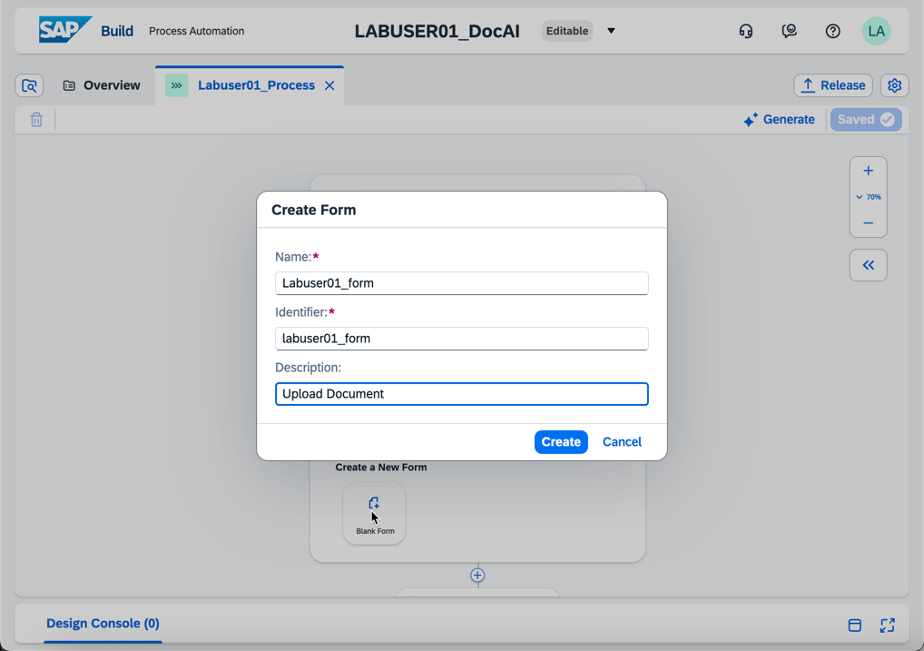

1. Click Create
2. Click the dots  next to the form and select Open Editor

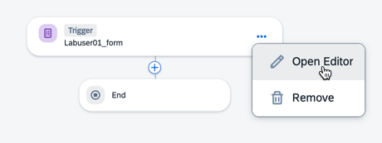

1. Drag the ‘Upload File’ button to the Form Canvas

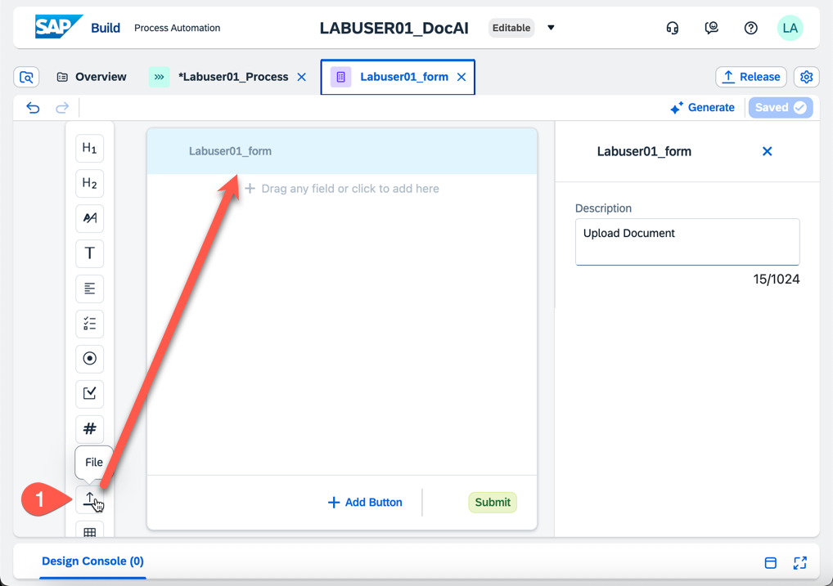

1. Enter a Field Header Text; for example ‘Upload Your File’
2. Maximum Number of Files is ‘1’
3. Required is Checked

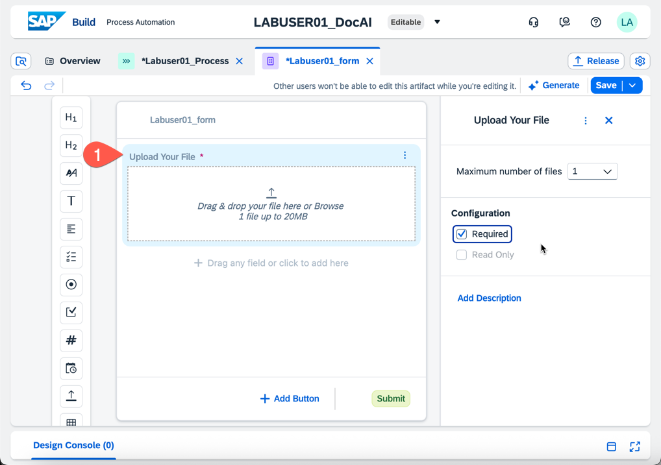

1. Next, we’re going to add a field to input a *SchemaID.* This is not something we would ask an enter user to select. We’ve added to the demo to show how we can add input fields to a form.
2. Select the *Text* icon and drag to the canvas. Enter *SchemaID* as the field header, check the box for Required.

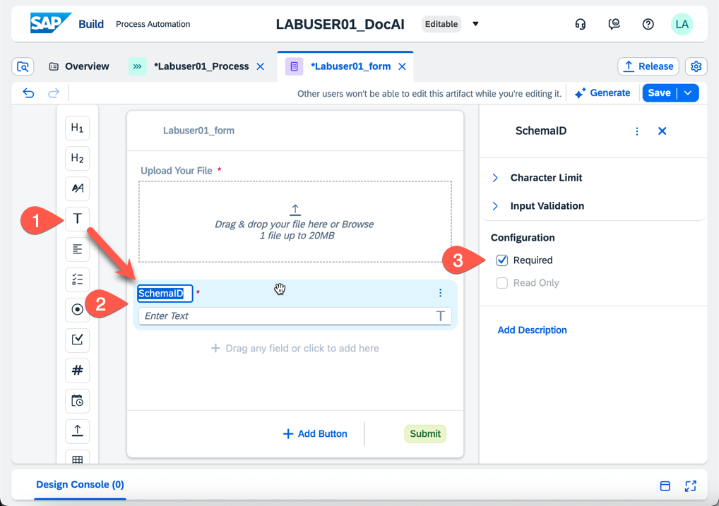

1. Click Save and then close the form tab within the SAP Build UI by clicking the blue 
2. You’re now viewing your Process. Click the  icon below your Form
3. Select *Automation* then *Blank Automation*

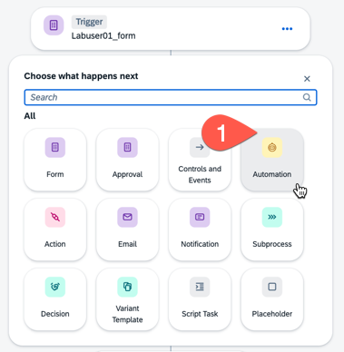

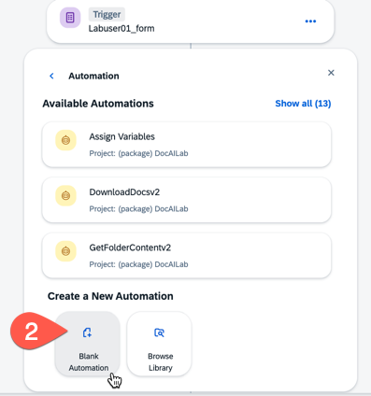

1. **IMPORTNANT**: Select *SKIP* when prompted to Detect Agent Version

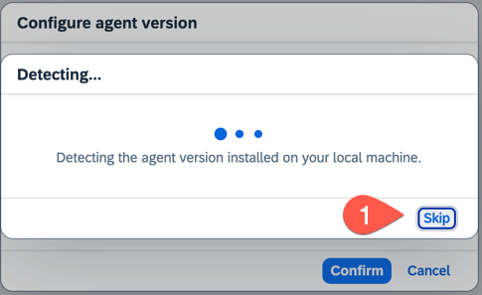

1. When prompted, select Agent Version 3.40 and check the boxes for Windows and Mac

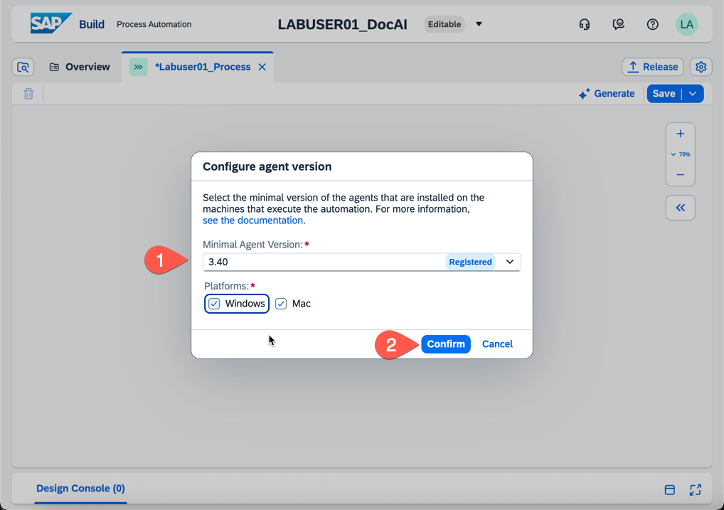

1. Enter the following value when prompted for Create Automation
   1. Name: Labuser##_Automation

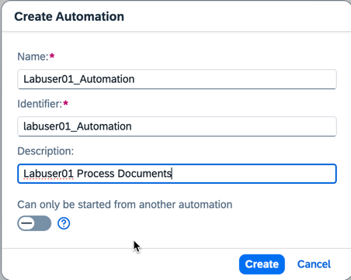

1. Click Create
2. Select the dots next to your newly created Automation and select Open Editor

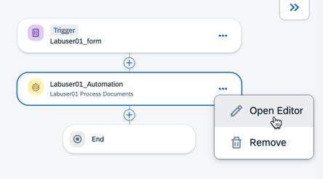

1. Before clicking on anything, select *Variables* under Automation Details on the right.
2. Add an Input Variable
   1. Name: folderID
   2. Type: String
3. Add an Output Variable
   1. Name: filePath
   2. Type: String

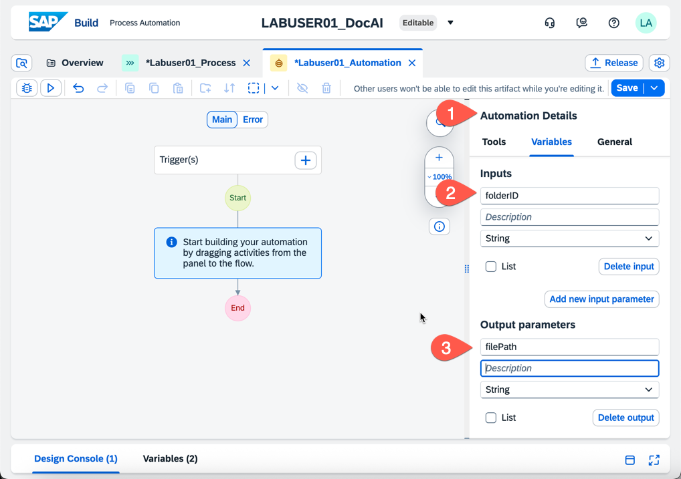

1. Click Save
2. Select Tools under Automation Details then expand Automations
3. Type ‘GetFolder’ in the Search box
4. Drag and drop the automation ‘GetFolderContentv2’ to the canvas after Start

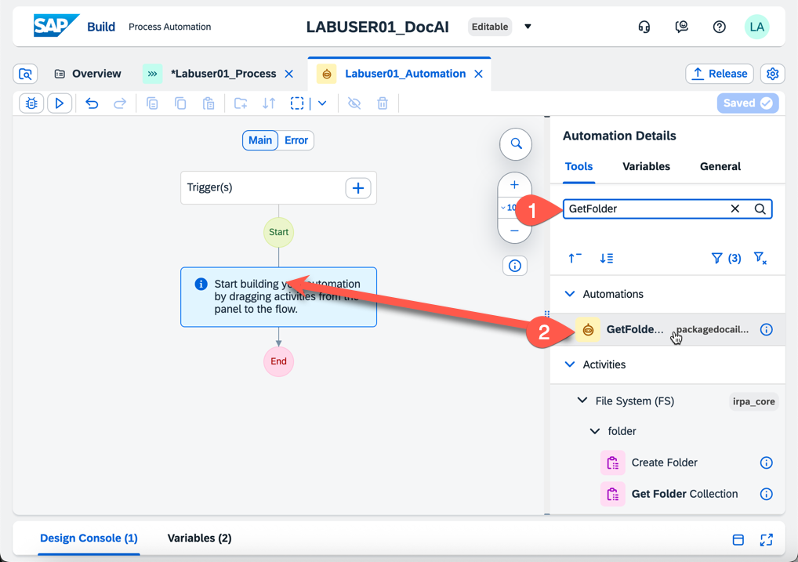

1. There will be a red X on the automation you just added.
2. Click on the Automation
3. Click the Pencil next to the Input Parameter *folderID*

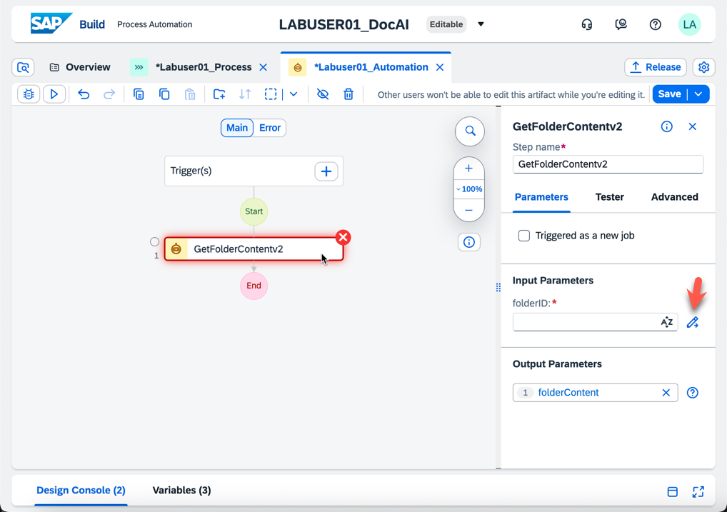

1. Expand Variables and select folderID. The expression editor will read Step0.folderID

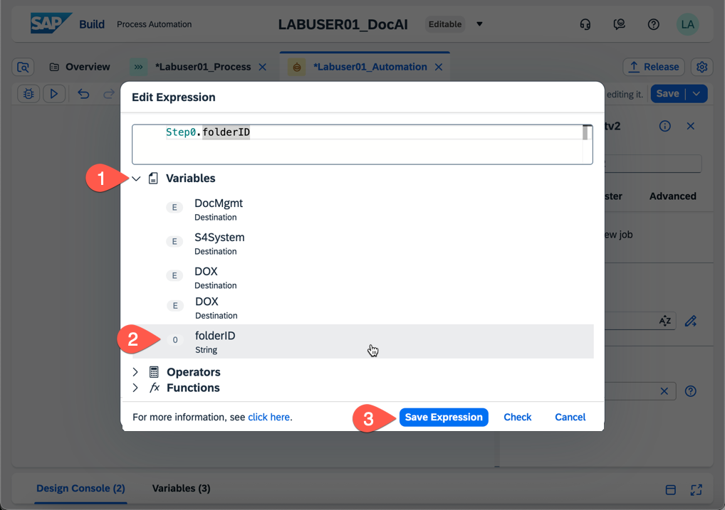

1. Click Save Expression
2. Next, click any blank grey part of the canvas to remove the focus on the automation you just added.
3. Under Tools, Search ‘Download’ and select the Automation ‘DownloadDocsv2’. Drag the automation to the canvas just after the previous automation.

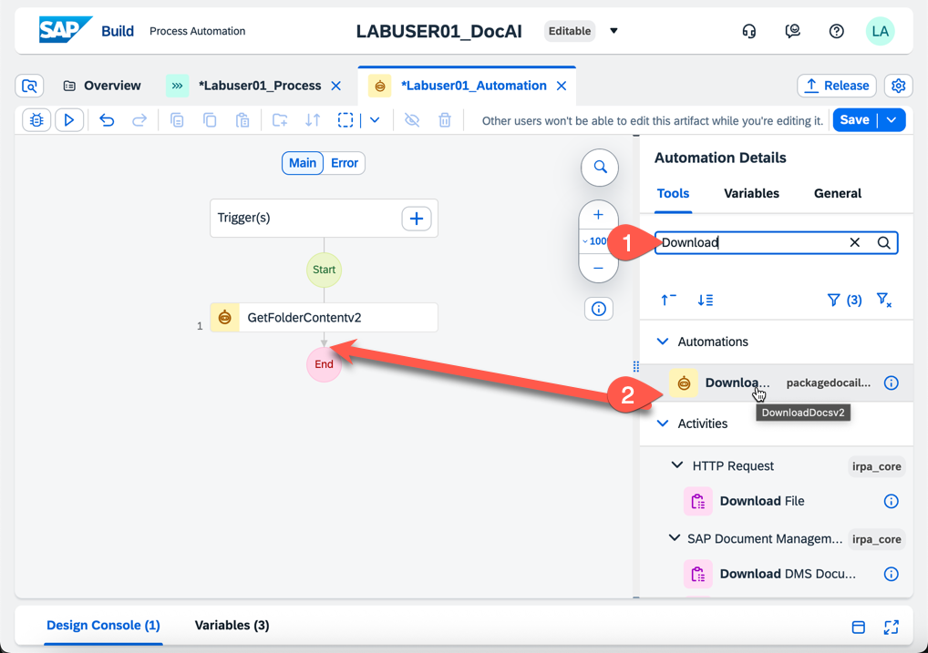

1. Your newly added automation will had a red X. Select the Automation
2. Under input parameters, click field that says DMS Object. Select the variable Folder Content

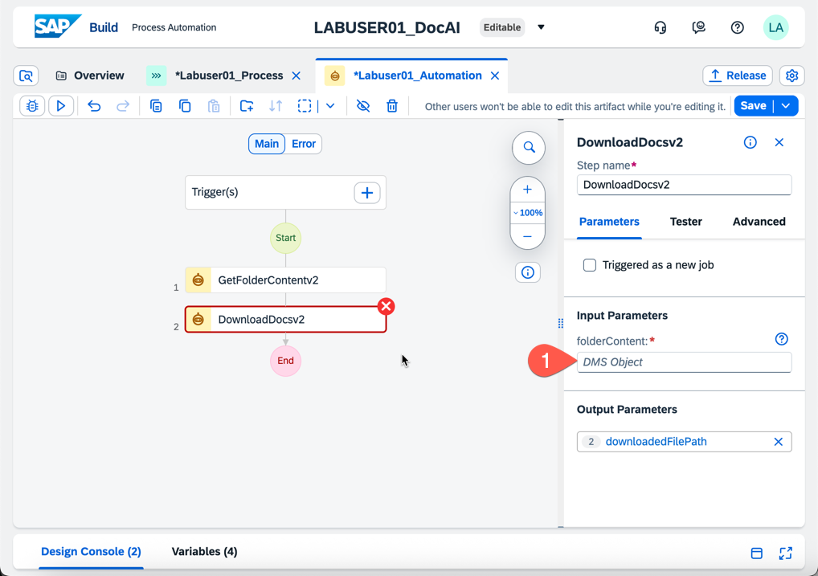

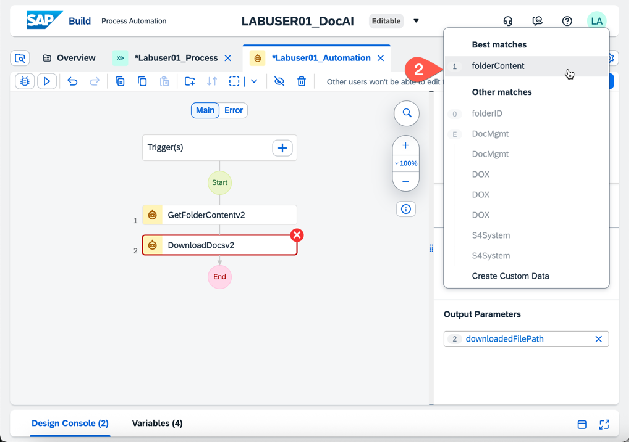

1. Once you select the correct variable the red x will disappear. See below.

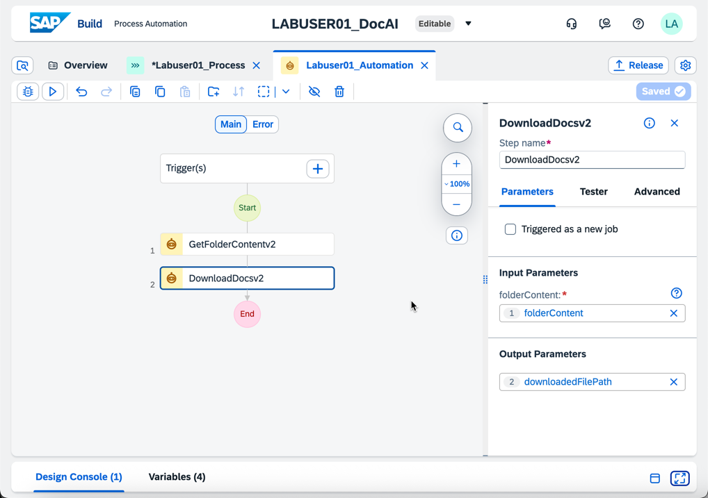

1. Next, select the ‘End’ red circle. The Output Parameter is empty. Click the pencil next to the parameter.

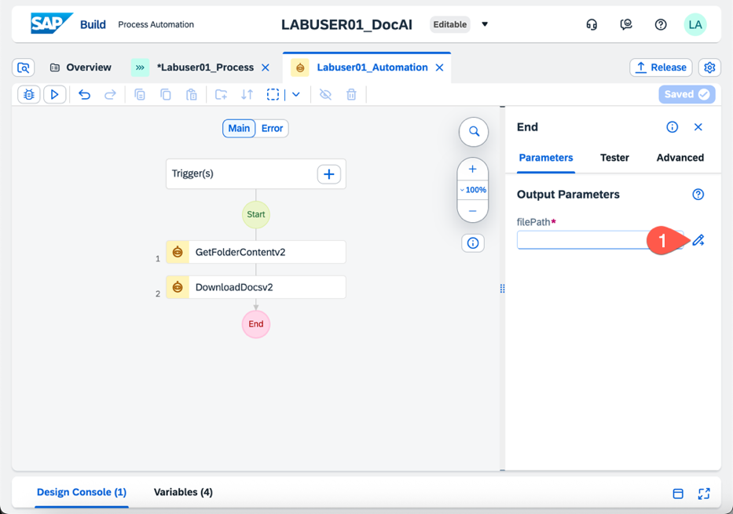

1. Select the variable downloadedFilePath and click Save Expression

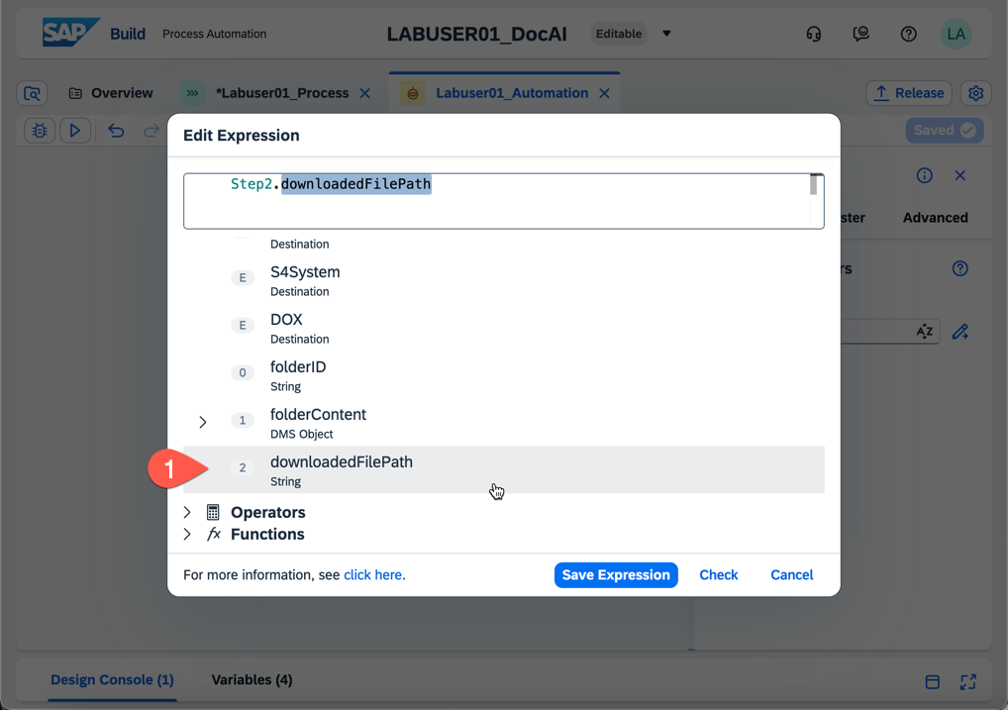

1. Click Save in the upper right to save the Automation
2. Next, click the expand button  in the lower right to view the Design Console
3. No errors should be displayed

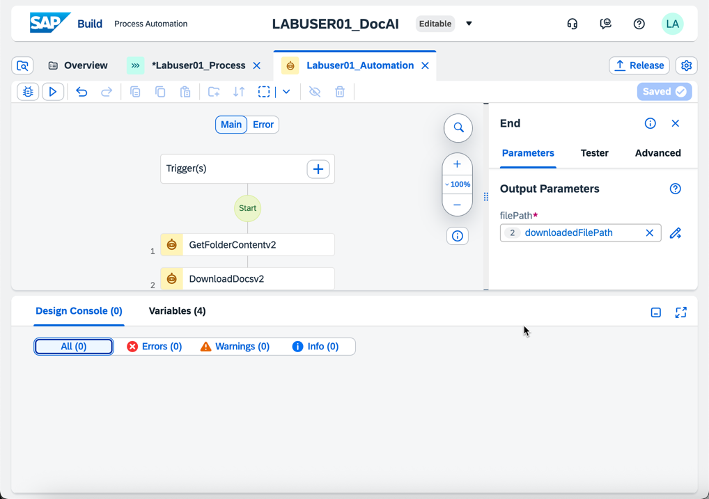

1. Close the automation by clicking the X on the tab within the developer UI
2. Minimize the Design Console by clicking the  button in the lower right
3. When we return to our process, we can see the Automation needs an Input Parameter defined.

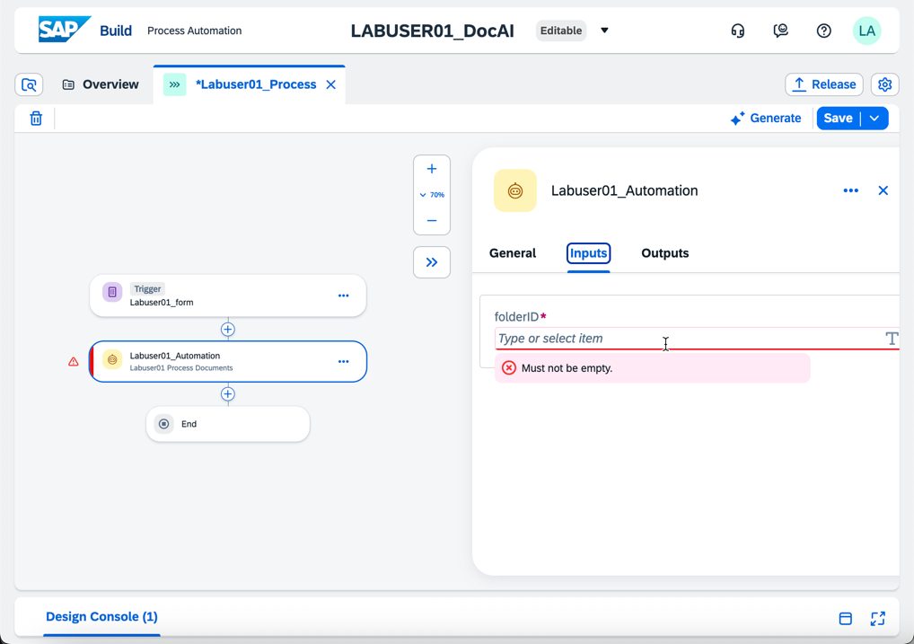

1. Click on the field and select the Form Field you created in the Form above.

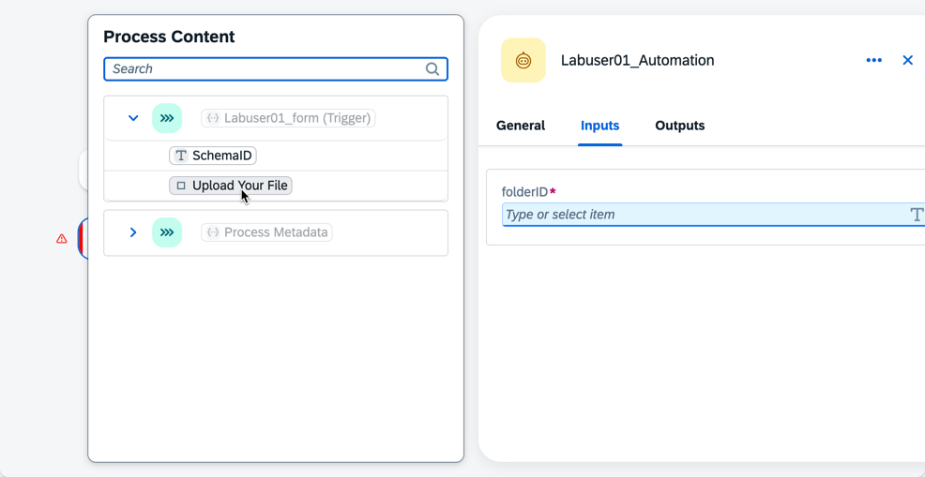

1. Click Save and the error is removed.

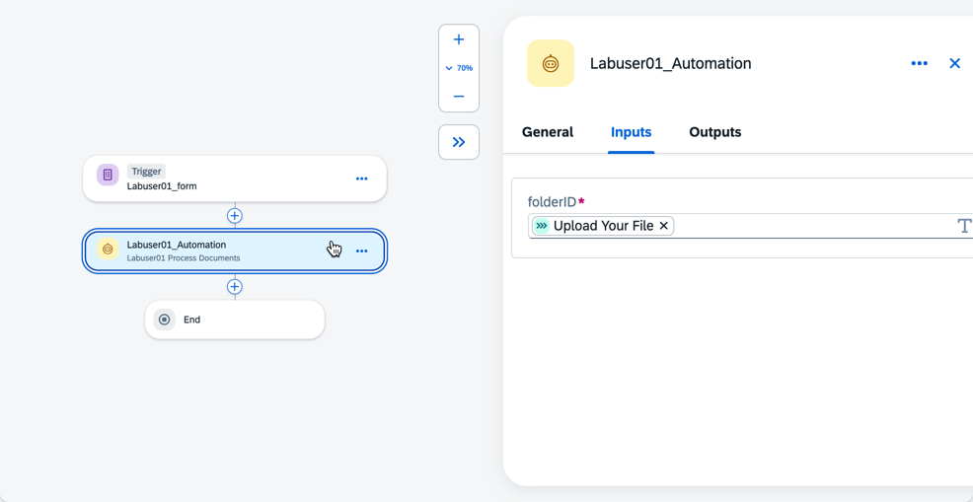

1. Click the *Add Step*  button under the automation we just added.
2. This time we’re going to select Automation > Show More
3. Scroll Down until you see *DocAI - Extract with Schema*

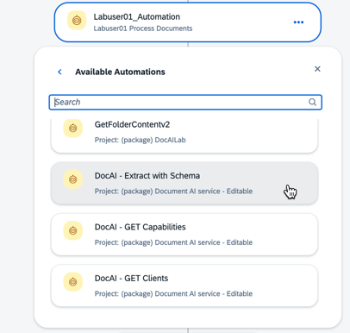

1. When you add the Automation it will have a red warning symbol. We need to update the Automation Input Parameters
2. Select the field ‘filePath’ for ‘filetoUpload’ and your SchemaID variable for SchemaName

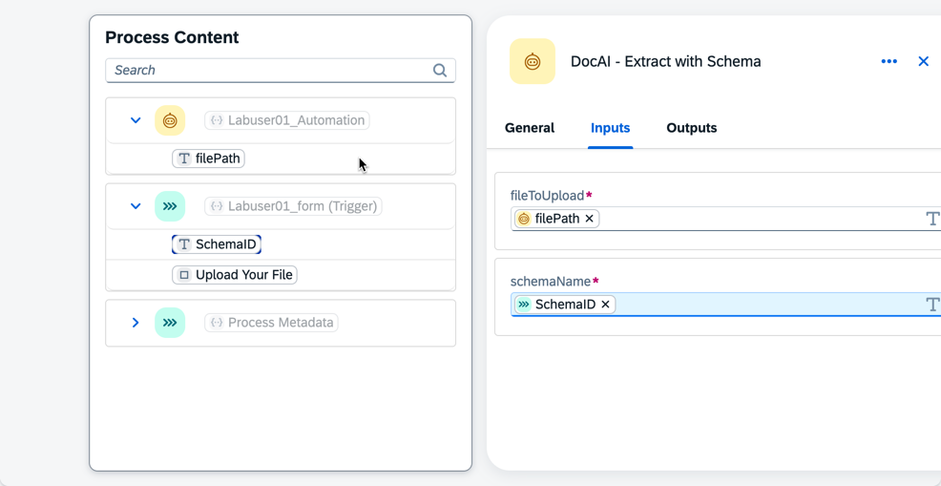

1. Click Save and the no errors or warnings are displayed

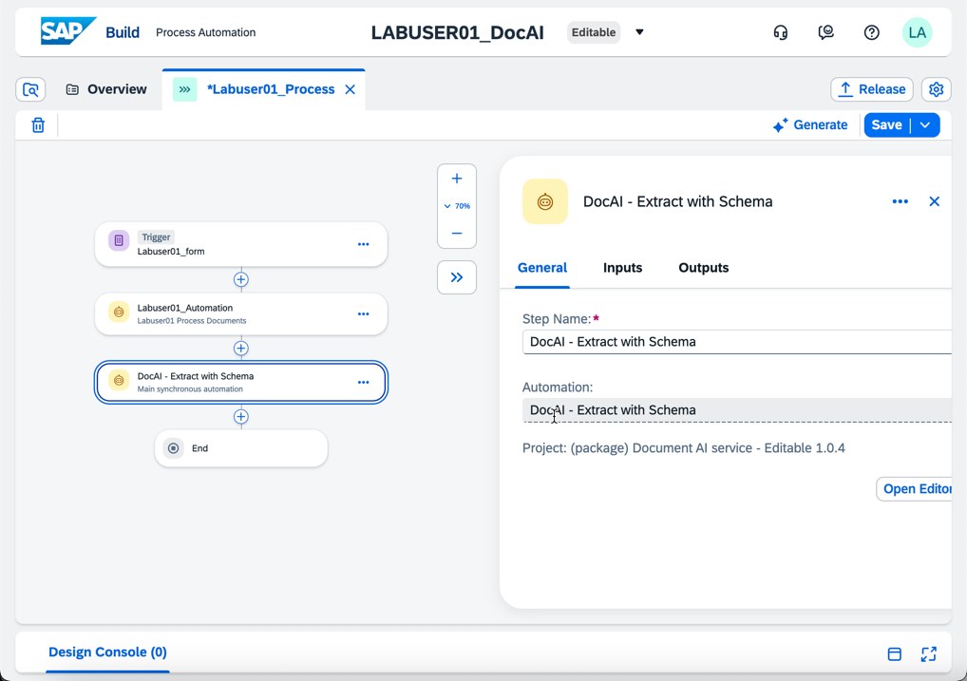

1. Next, we’re going to add an automation to extract the variables from the SAP Document AI JSON response.
2. Click the *Add Step*  button under the ‘DocAI – Extract with Schema’ automation.
3. Select Automation and then select ‘Assign Variable’ from the DocAILab Package.

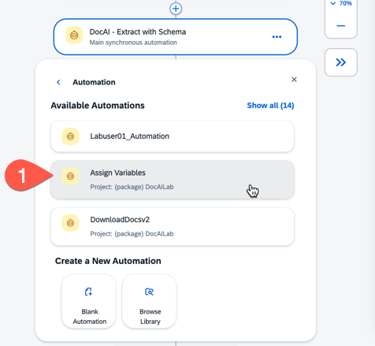

1. Again, we can see the red warning and we need to resolve the Inputs.

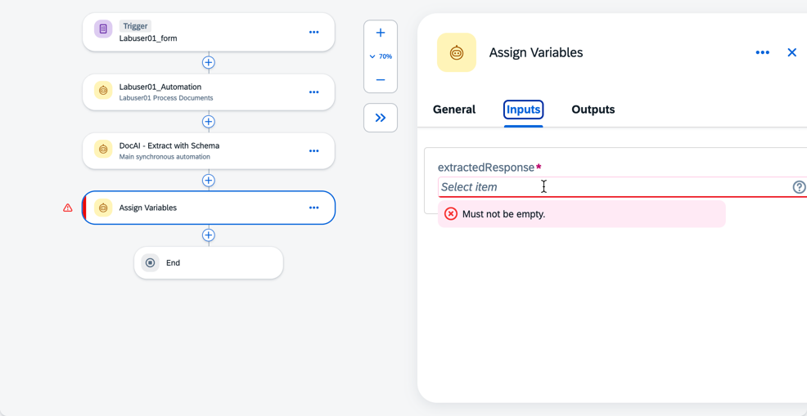

1. Select ‘extractedData’ as the value for extractedResponse

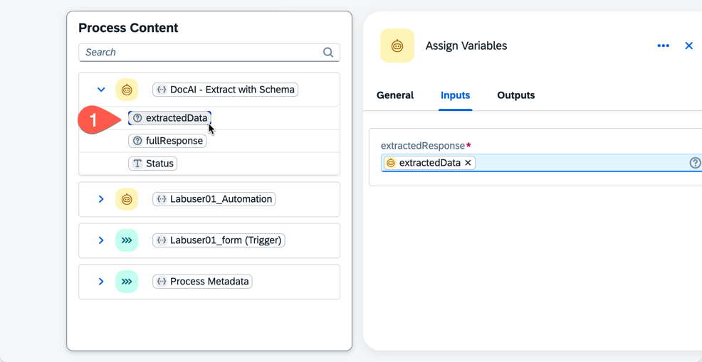

1. Click Save
2. And as a last step, we’re going to add the API call to SAP S/4HANA.
3. Click the *Add Step*  button again, and this time select Action

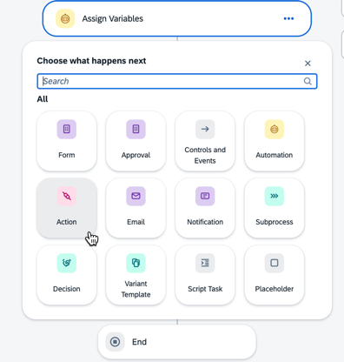

1. Select the Action *Creates a material document* from the Package Project: S4 Material Documents - Read, Create 1.0.0

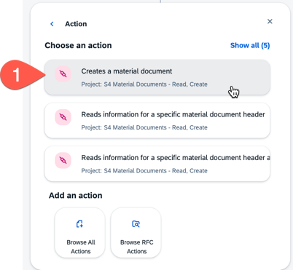

1. Click on the Action and set the Destination to S4System

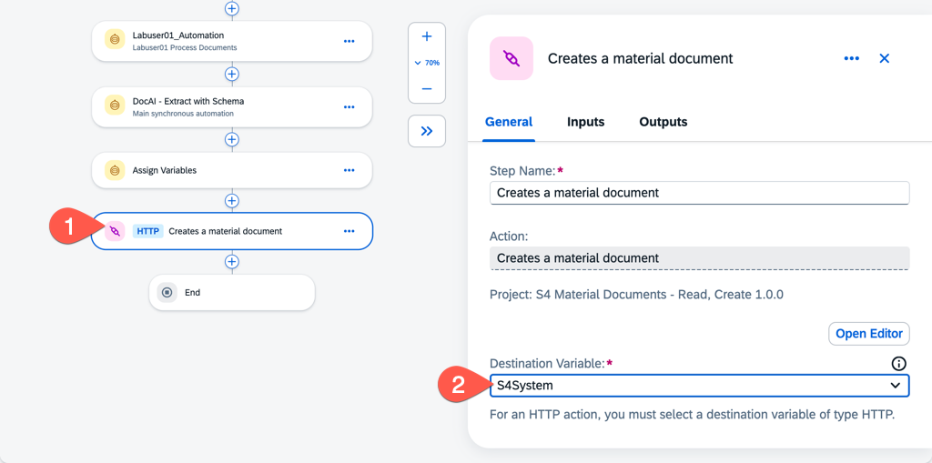

1. Click Save and then select the Input Tabs
2. We’re going to hard code some variables in the spirit of completing the lab quickly. In a production scenario we would create and manage variables for Plant, Movement Code, Posting Date, and more.
3. Please update the following Inputs on the Action ‘Creates a Material Document’
   1. Select “Single Properties” for to_MaterialDocumentItem
4. Values & Variables for Action
   1. GoodsMovementCode: 04
   2. PostingDate: YYYY-MM-DDT00:00:00
      1. For example: 2025-10-19T00:00:00
   3. Expand >Results
   4. Material: variable out_Product
   5. Movement Type: 311
   6. Plant: 1710
   7. Quantity in Entry Unit: variable out_Qty
   8. Rec/Iss Plant: 1710
   9. Storage Location #1: variable out_SourceBin
   10. Storage Location #2: variable out_TargetBin
5. Example below

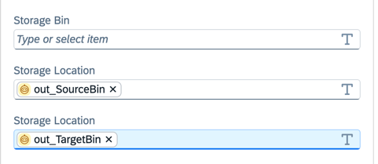

1. Click Save and close the Process in the developer UI

# Add a Data Type

1. Next, we’re going to return to the view of your artifacts.
2. Click the Create Button and Select Data Type

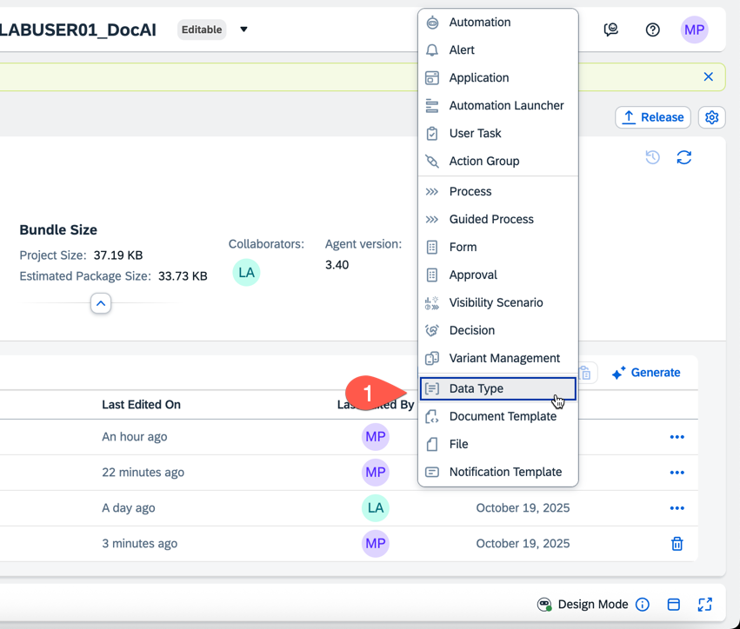

1. Give enter the details below
   1. Name: DMS Objects
   2. Identifier: dmsobjects
   3. Description: DMS Objects
2. When viewing your data type, create three Fields by clicking the New Field Button.

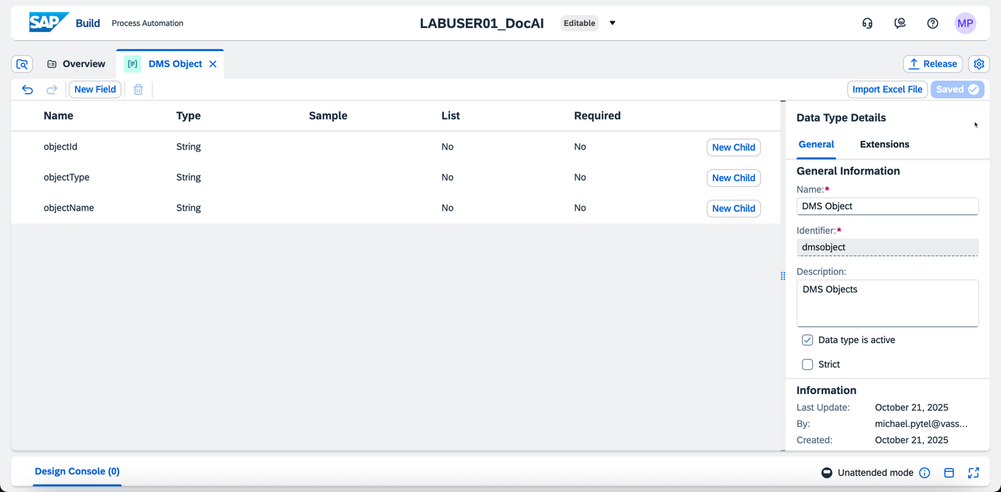

1. Click Save and close the DMS Object.

# Deploying your Automation

1. Next, we’re going to click the Release Button

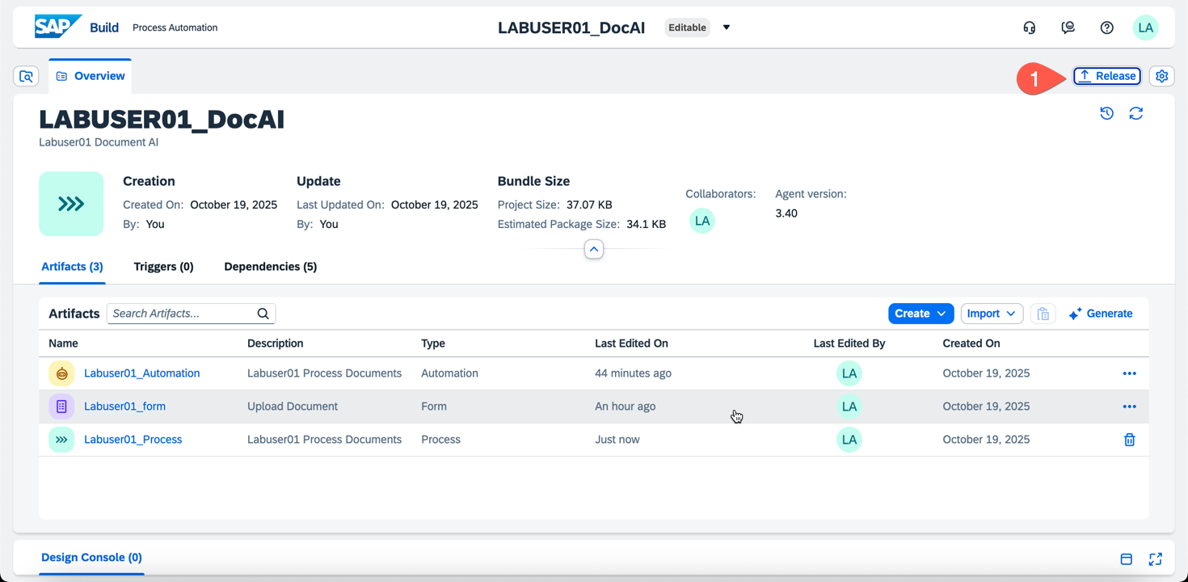

1. Accept the defaults on the ‘Release Project’ modal and click Release

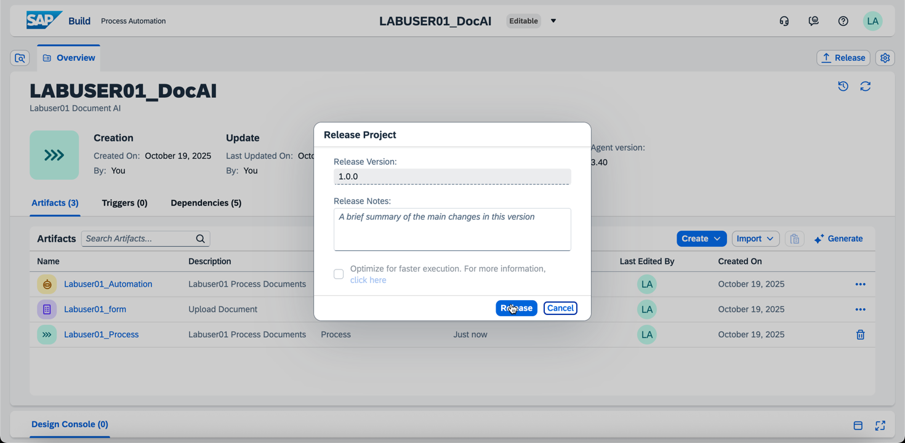

1. After releasing the project we will click the upper middle of the screen to select the newly released version of our project.
2. Next we will click the Deploy button

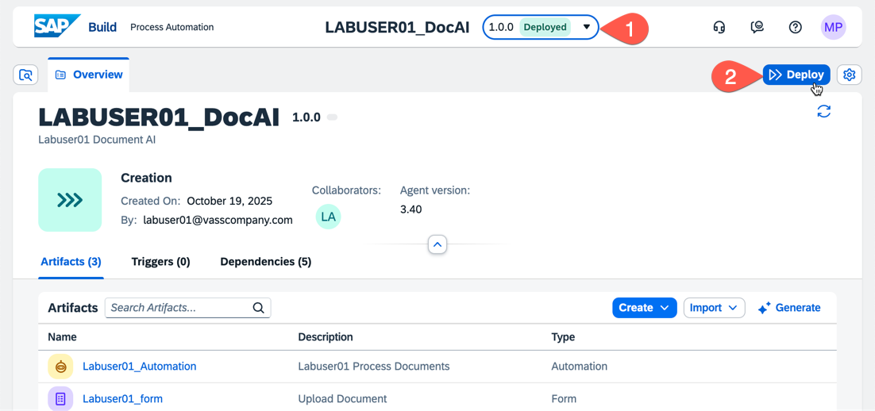

1. Once the deployment finishes we can test our form!
2. Select your deployed version, then select the process and then the form
3. Click the button for “Link to Form” to open the Form in a new tab
4. 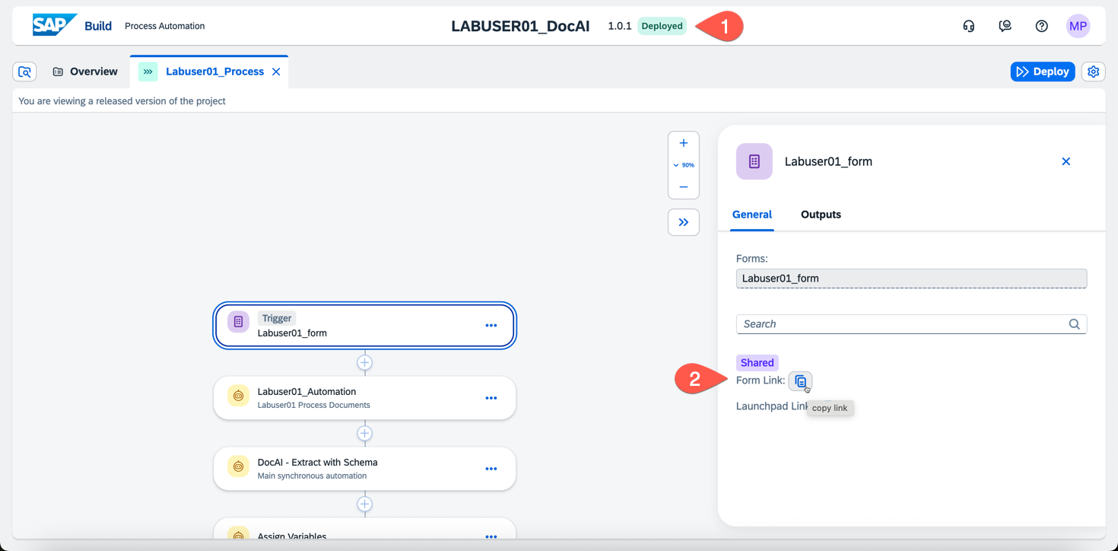
5. Upload your Labuser Goods Movement Form to process!

# Monitoring and Logging in SAP Build

1. From the SAP Build Lobby (<https://vass-sap-build-ai2.us10.build.cloud.sap/lobby>)
2. Click on Monitoring

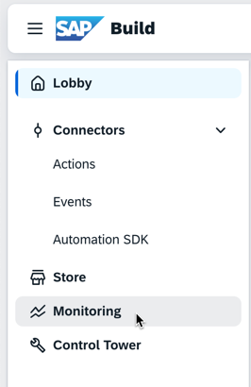

1. Click the button for Automation Jobs, set your date filters to explore job logs.

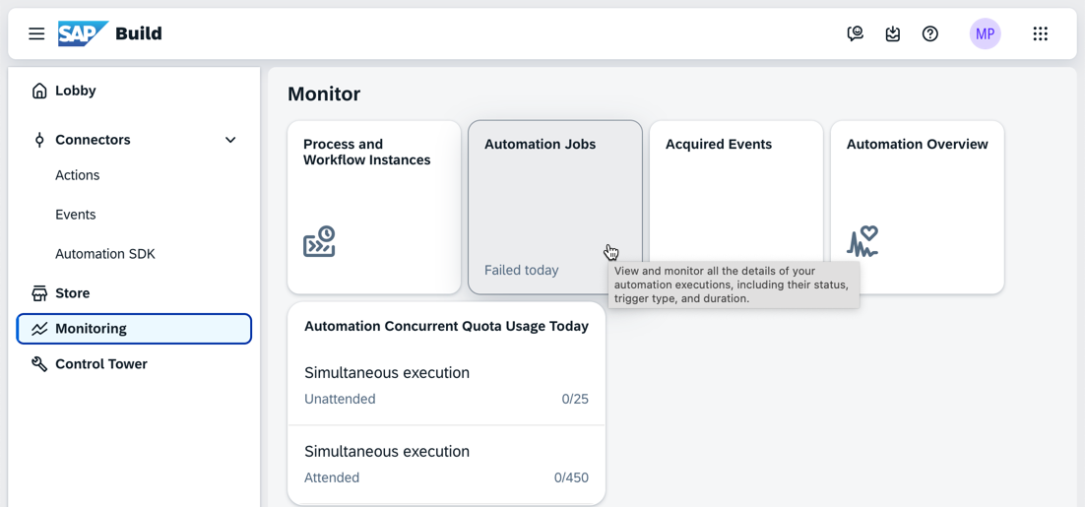

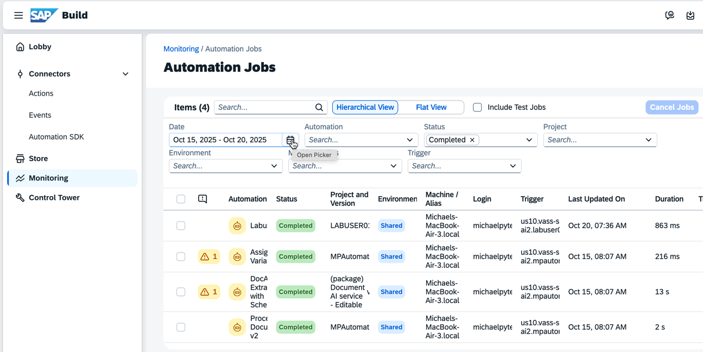

1. In each log you can see the processing output and input variables between automations.

Thank you for completing our Hands-On Lab! Please email if you have any questions!